CECV Commitment Statement to Child Safety
A safe and nurturing culture for all children and young people in Catholic schools
The Statement is intended to provide the central focus for child safety across Catholic education in Victoria, built around a unified understanding of the moral imperative and overarching commitments that underpin our drive for improvement and cultural change.
The Catholic school sets out to be a school for the human person and of human persons.
‘The person of each individual human being, in his or her material and spiritual needs, is at the heart of Christ’s teaching: that is why the promotion of the human person is the goal of the Catholic school’.
(Congregation for Catholic education 1997, par. 9)
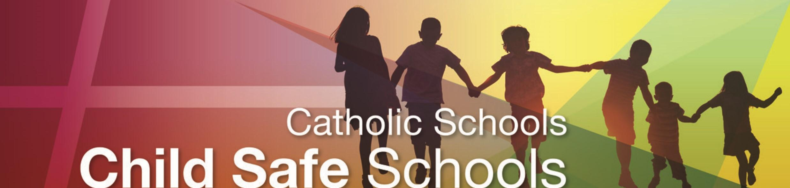
The Catholic Education Commission of Victoria Ltd (CECV) holds the care, safety and wellbeing of children and young people as a central and fundamental responsibility of Catholic education. This commitment is drawn from and inherent to the teaching and mission of Jesus Christ, with love, justice and the sanctity of each human person at the heart of the Gospel.

The CECV has a universal expectation for the protection of children. It is resolutely committed to ensuring that all those engaged in Catholic education in Victoria promote the inherent dignity of children and young people and their fundamental right to be respected and nurtured in a safe school environment. This is particularly so for the most vulnerable children, including Aboriginal and Torres Strait Islander children, children from culturally and/or linguistically diverse backgrounds, and children with a disability.
Catholic schools have a moral, legal and mission-driven responsibility to create nurturing school environments where children and young people are respected, their voices are heard and where they are safe and feel safe. When allegations of abuse concerning children and young people are raised, Catholic schools will take prompt action to have these appropriately referred and investigated. While the context and reality at each Catholic school will differ, the fundamental issues of understanding effective practices in child safety and identifying and responding to child harm remain the same. All schools must strive for continual improvement that is responsive to emerging thinking, evidence and practice, so as to eliminate the possibility of abuse occurring in the first place.
Creating child-safe school environments is a dynamic process that involves active participation and responsibility by schools, families and their communities. It is marked by collaboration, vigilance and proactive approaches across policies, procedures, curriculum and practices.
Every person involved in Catholic education has a responsibility to understand the important and specific role he/she plays individually and collectively to ensure that the wellbeing and safety of all children and young people is at the forefront of all they do and every decision they make.

The CECV commits to providing a safe and nurturing culture for all children and young people in Victorian Catholic schools through:
- Upholding the primacy of the safety and wellbeing of children and young people.

At all times, the ongoing safety and wellbeing of all children and young people will be the primary focus of care and decision-making, with particular attention paid to the cultural safety of Aboriginal and Torres Strait Islander children and children from culturally and/or linguistically diverse backgrounds, as well as the safety of children with a disability.
To create and maintain a safe and nurturing culture, schools will actively and continually develop and review all policies, processes and practices, informed by emerging thinking and evidence.

- Empowering families, children, young people and
staff to have a voice and raise concerns.

Schools, in partnership with families, will ensure children and young people, are engaged and active participants in decision-making processes, particularly those that have an impact on their safety.
This means that the views of staff, children, young people and families are taken seriously and their concerns are addressed in a just and timely manner. Children and young people are also provided with the necessary skills and knowledge to understand and maintain their personal safety and wellbeing.

- Implementing rigorous risk-management and employment practices.

Schools will systematically and continually identify and assess risks to child safety and will eliminate (where possible) or reduce all potential sources of harm. Effective risk management will be embedded in school life through effective, transparent and well-understood policies, procedures and practices.
Schools will employ highly competent and professional staff who are formed and challenged to maintain the safety of all students. The high-quality of staff appointments will be upheld through rigorous employment and staff review processes and practices.
Catholic education will stay abreast of current legislation and will meet their legislative duties to protect the safety and wellbeing of children and young people in their care, including the Victorian Child Safe Standards (Victorian Government 2016), mandatory reporting, grooming, failure to disclose and failure to protect requirements.

References
Congregation for Catholic education 1997, The Catholic School on the Threshold of the Third Millennium, Vatican, Vatican City, accessed 24 February 2016 www.vatican.va/roman_curia/congregations/ccatheduc/documents/rc_con_ccatheduc_doc_27041998_school2000_en.html.
State of Victoria, Department of Education and Training 2016, Child Safe Standards – Managing the Risk of Child Abuse in Schools Ministerial Order No. 870, Education & Training Reform Act 2006, Gazette No. S2, accessed 16 May 2016 www.gazette.vic.gov.au/gazette/Gazettes2016/GG2016S002.pdf.

As defined by the Victorian Government Special Gazette No. 2 (2016), ‘children and young people’ in this document refers to those children and young people enrolled as students in Catholic schools in Victoria.

